
CPIT 210 Computer Organization and

Architecture Project Fall 2024

BCD to 7 segment

decoder

From:
Abdullah Bahumayed ID:2338393
&
Mohammed Alahmadi ID: 2340345

To:
Wagdy Alghamdi

Table of Contents
Cover page…………………………………………………………………………………………………………………………………………….1
Introduction 3
What is the BCD to 7 segment decoder? 3
Project proposal 4
Objectives: 4
Outcomes: 4
Components 5
Circuit Operation 6
Step 1: Design the truth table 6
Step 2: Design the BCD circuit 7
Step 3: Design a counter 8
Step 4: Split the value (output) 9
Step 5: Connecting the outputs 10
The hardware 11
Step 1: The input 12
Step 2: The 7447 IC decoder 13
Step 3: The output (7 segments display) 14
Conclusion 15
Reference 16

Introduction

With the development of science and technology, the application field of diode is more and more extensive. The main advantages of diode are small size, low price, various colors, long service life, easy access, and easy interface with various other digital circuits and electronic components. Due to their small chip size, so many of them can be connected together in a compact and small
package to produce, which is commonly referred to as
a 7-segment display.

What is the BCD to 7 segment decoder?

The BCD to 7 segment decoder is a program that allows to make a digital clock using Combinational Circuits tools. For example, AND gate, OR gate, XOR gate.
The input is 4 binary numbers long, so when the input is “0100” the output should be “4” in decimal digits.

Project proposal

In BCD, each decimal number (0-9) is represented by its 4-bit binary form. A seven-segment display is a device that contains seven Light Emitting Diode (LED) so, it can represent the binary numbers in decimal form using these lights. Our objectives and outcomes from this project:

Objectives:

- Represent any binary number from (0-9) in the decimal form using the BCD to seven-segment decoder.
- Design the truth table.
- Design the BCD circuit using combinational circuits tools, like AND gates, Or gate and NOT gate.
- Using a clock to make the program switching from state to another in an efficient way.
- Using a counter, so that the program will continue working from (0-9). So, when it displays the last number, the program come back to the start and do it all over again.

Outcomes:

- The seven-segment displayer should works based on the outputs of the BCD to seven-segment decoder, that each line should work based on its output. So, if output a is 1 then the line on the displayer should work.
- The seven-segment displayer should work in a sequential order, so the program should go from (0-9) and goes back again.
- The BCD circuit should come up with outputs that matches the truth table.
Circuit Components

To do this program, you need to understand the way the program works and what will be needed to make it doable. Here are the components that are needed to complete the program.

Components:

- Combinational circuits tools: AND gate, OR gate and NOT gate, etc. To make any circuit you need those gates.
- Seven-segment LED display: It shows us the output of the entire program and if it is working right or need some adjustment.
- Truth table: Shows the inputs and outputs for the BCD to seven-segment decoder.
- A clock: Input clock element, every time the clock gets high the counter increments by one.
- A counter: Make the program works in a loop from (0-9).
- reset button: Input, when high it reset the counter to zero
- max value: It is connected to the counter. Its to establish an ending point which is the maximum value that the counter will reach.
- A splitter: The output of the counter will be in 4-bit binary. The splitter job is to split this 4-bit from each other so, each bit will be connected to the 4 inputs in the BCD to seven-segment decoder.
- BCD to seven-segment decoder: A circuit the takes 4 inputs and produce 7 outputs each one of them is connected to the Seven-segment LED displayer.

Circuit Operation

Now, we will show step-by-step explanation of the circuit operation from the very start until the end to make it clear for anyone to understand it.

Step 1: Design the truth table

The truth table is considered as the first step of creating any kind of circuit because it’s basically the road map of the circuit. And from it you can come up with an expression for every output you have, so, a, b, c, d, e, f, and g each one of these outputs have their own expressions.
A | B | C | D | a | b | c | d | e | f | g
0 | 0 | 0 | 0 | 1 | 1 | 1 | 1 | 1 | 1 | 0
0 | 0 | 0 | 1 | 0 | 1 | 1 | 0 | 0 | 0 | 0
0 | 0 | 1 | 0 | 1 | 1 | 0 | 1 | 1 | 0 | 1
0 | 0 | 1 | 1 | 1 | 1 | 1 | 1 | 0 | 0 | 1
0 | 1 | 0 | 0 | 0 | 1 | 1 | 0 | 0 | 1 | 1
0 | 1 | 0 | 1 | 1 | 0 | 1 | 1 | 0 | 1 | 1
0 | 1 | 1 | 0 | 1 | 0 | 1 | 1 | 1 | 1 | 1
0 | 1 | 1 | 1 | 1 | 1 | 1 | 0 | 0 | 0 | 0
1 | 0 | 0 | 0 | 1 | 1 | 1 | 1 | 1 | 1 | 1
1 | 0 | 0 | 1 | 1 | 1 | 1 | 1 | 0 | 1 | 1

Step 2: Design the BCD circuit

On step one, we establish the truth table of the BCD to seven-segment decoder. Now, we going to see how this circuit looks like and how many gates we used to design it. On figure. 1, you can see that the inputs are (0000) which has the value of (0) if you turn it to decimal. This is the first row of the truth table and if you make the inputs (0001) the value in decimal will be (1) and the outputs will be different as we saw in the truth table.
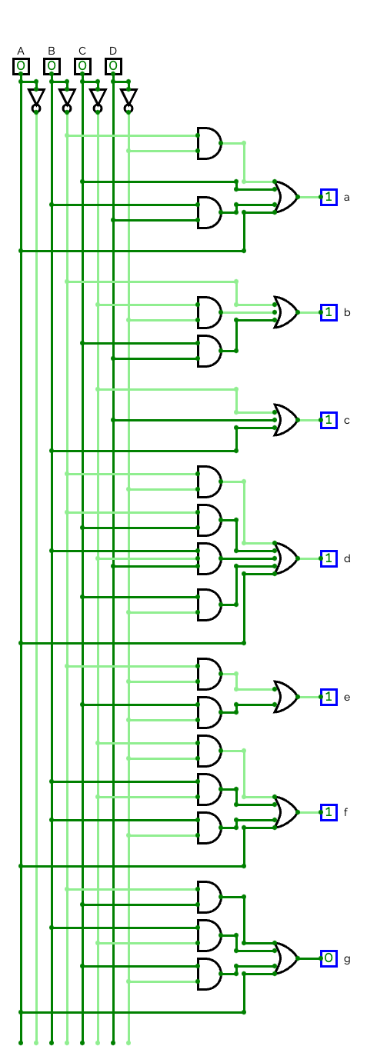
Figure. 1: BCD circuit

Step 3: Design a counter

To keep the program running in a sequential order you need a counter. The counter job is to keep running the program repeatedly, its start at zero and end at the max value the programmer should insert. Anyway, in the following picture it will shows how the counter should be designed.

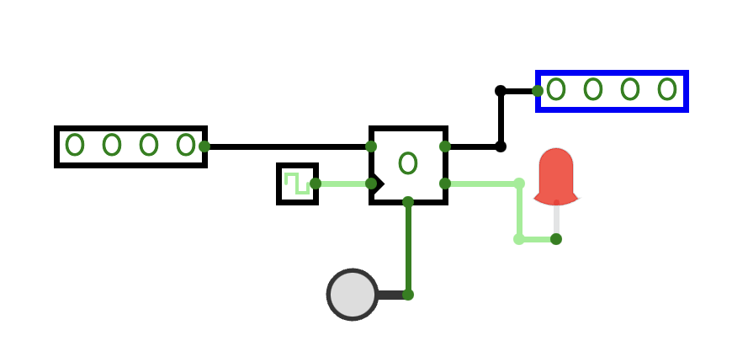
Figure. 2: A counter

So, the input on the left is the max value input which contains 4-bit binary number. It establishes the maximum value that the counter will reach. As you can see right down to the max value is the clock, every time it gets high the counter increments by one. Down straight to the counter is reset button, when you press it, it will go back to the start (Zero in this case). The last component in the counter is called “Value” or the output of the counter.

Step 4: Split the value (output)

Going through the process of creating a counter I had a problem, the counter was producing an output with 4-bits and I needed to connect this output to the BCD to seven-segment decoder that I created, but the problem was that the BCD to seven-segment decoder takes 4 inputs so, I needed to split this 4-bit from each other using the splitter.

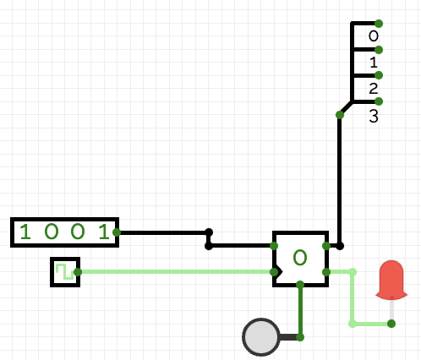
Figure. 3: A counter with a splitter

Is you can see here, we have set a max value at (1001) which is (9) in decimal form and split the 4-bit output of the counter form each other, now all is left is to connect the splitter dots into the inputs of the BCD to seven-segment decoder.

Step 5: Connecting the outputs

Now, we learned how to create the BCD to seven-segment decoder circuit. All is left is to connect its outputs to Seven-segment LED displayer and every output will go to a specific point to make the program works correctly.
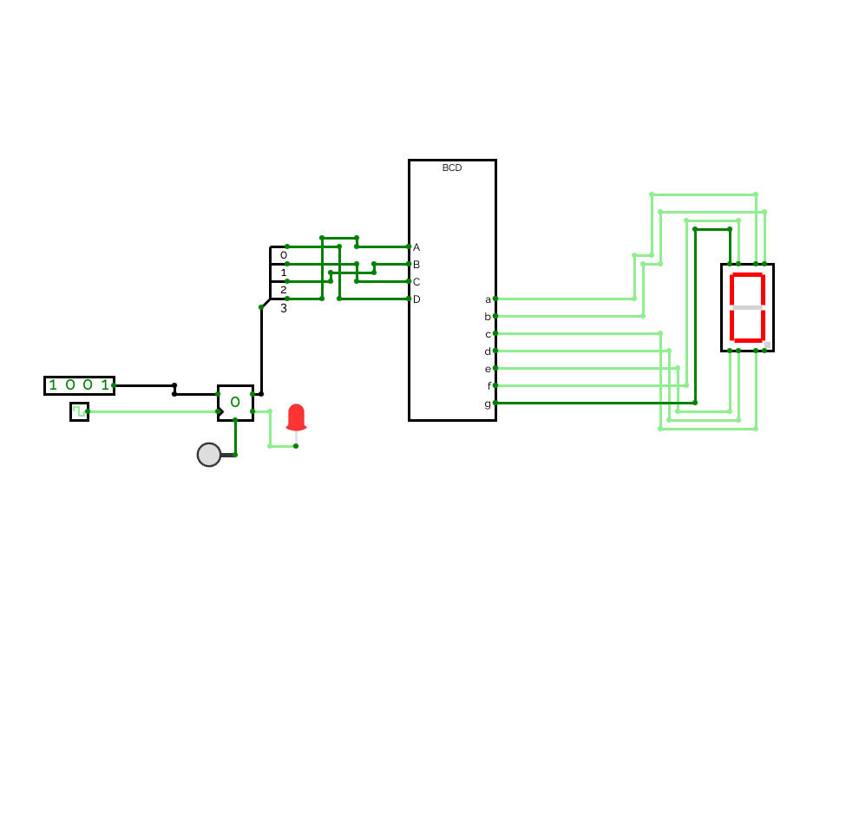
Figure. 4: BCD to seven-segment decoder

The hardware

In the hardware, we went through many difficulties, including finding a store that had all the items and also installing them, but after 3 full days of hard work, we were able to complete the hardware perfectly.

The hardware consists of 3 steps: 1. The input, then the data is transferred to 2. The decoder, and then 3. The final result is displayed on the 7-segment display.

You can see a picture of our hardware here in figure. 5.
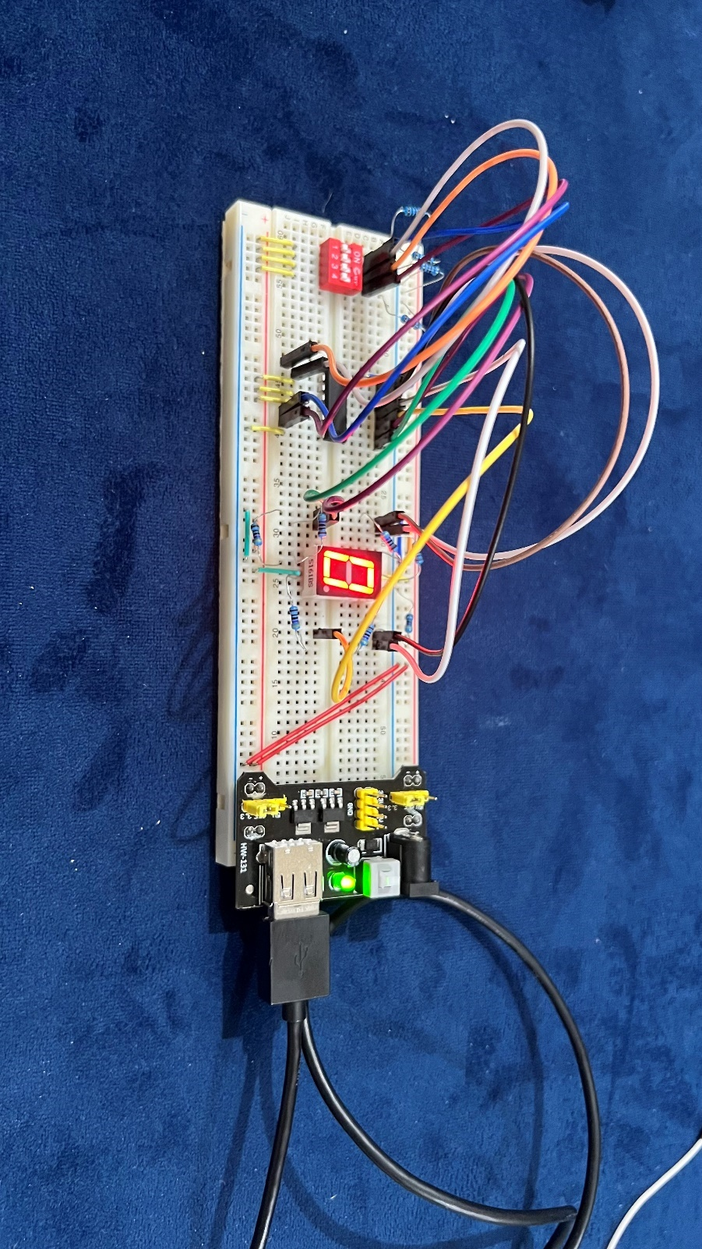
Figure. 5: overview of our hardware

Step 1: The input

We used the 4-pin switch as the input. For example, if we open the third pin and the input is 0100 as you see in Figure. 6, it will transfer this signal to the decoder 7447, which will take us to the next step.

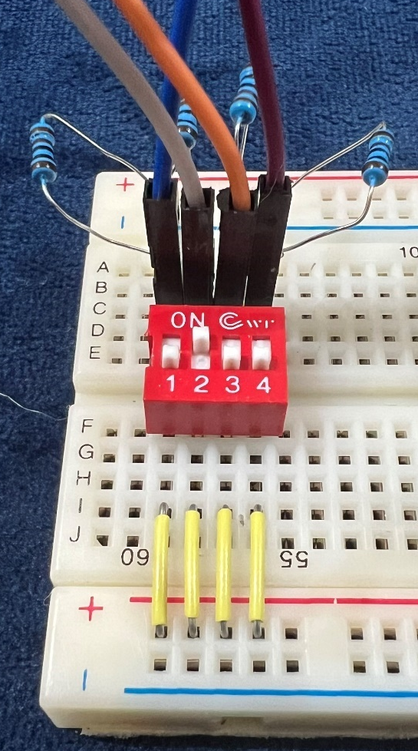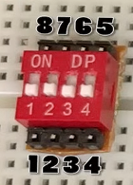
Figure. 6 & 7: the switch with 0100 input

The switch has 8 places to deal with. The first 4 we must connect them to the power. And the last 4 we connect them to the decoder with 4 resistors connected to the ground.

Step 2: The 7447 IC decoder

Now as we say we put 4 wires from the places 5-8 from the switch to the decoder. As we know when the decoder takes 4 inputs it makes from them 8 outputs. See figure 8 & 9.

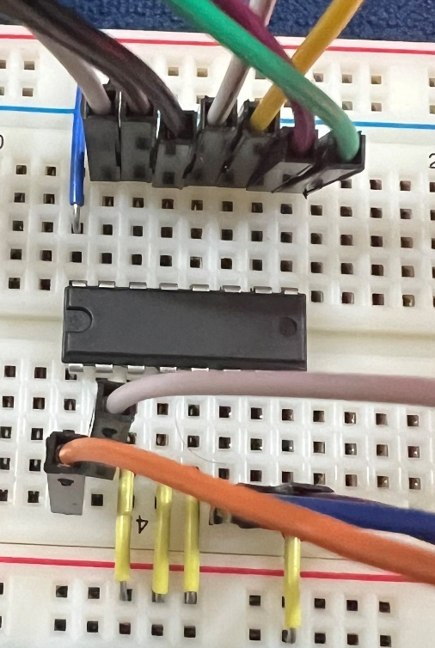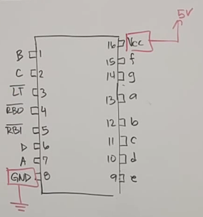
Figure 8 & 9: the decoder 7447

The decoder has 16 slots. As you see the number 8 goes to the ground and the number 16 goes to the power. The 4 inputs that we take from the switch go to the (A, B, C, D) from the left of the decoder. After that we have numbers (3, 4,5 ) that we do not need them, so we will put them to the power. The last (a, b, c, d, e, f, g) we need wire them to the step 3 (the 7 segments display)

Step 3: The output (7 segments display)

After we have done the 7 wires from the last step we should connect them to the 7 segments display. This display has 10 inputs as shown below at Figure 10 & 11.

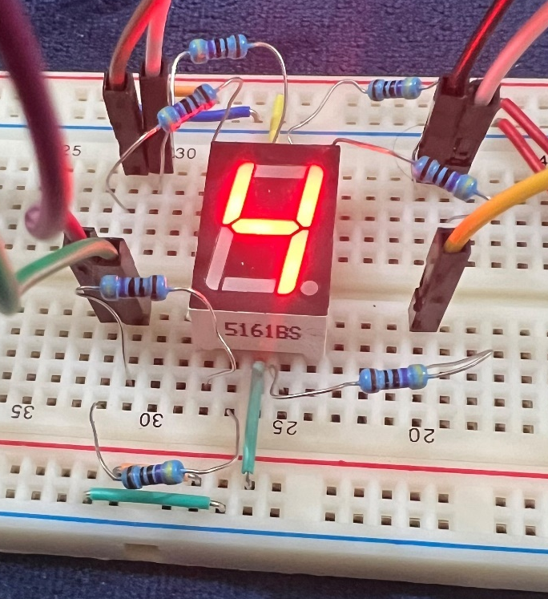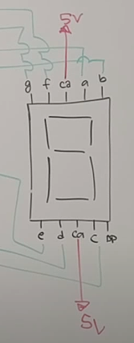
Figure. 10 & 11: the 7-segment display after we put 0100 in the switch

As I said the display has 10 inputs 5 down and 5 up. The middle one in each side must wired to the power. There is an extra one we do not need to use it in this project so we will let it empty. Then we will have 7 inputs to deal with, we take those 7 wires from the decoder earlier, and put them in the same alphabet as the output of the decoder, like (a) to (a) etc. In the switch we put 0100 that is 4 in decimal and the output is 4 in the display in Figure 10. So, the hardware is working.

Conclusion

After creating the program, we can honestly say that we overcome some tough challenges and of course we learned so much during the period we work on this project. We created a way to keep the program going and creating inputs by itself using the counter but we set a max value so it can end at a certain point, and we overcome a challenge when we needed to split the output of the counter. Also, creating the BCD circuit using the truth table and implementing all of these AND gates and OR gates. We also learned that the hardware could be little hard if you don’t know what the decoder and the logic gates is. This project made us know how the could just some of small pieces of hardware could make a whole mobiles and computers. The project took from us 1 week and we agreed to the fact of that week was the most helpful week we did.

Thanks to you doctor Wagdy for this great experience.

Reference

- Figure. 1: BCD circuit using combinational circuits tools, gates and all that.
- Figure. 2: the look of the counter.
- Figure. 3: A splitter that is connected to the counter output.
- Figure. 4: BCD to seven-segment decoder.
- Figure. 5: overview of our hardware
- Figure. 6 & 7: the switch with 0100 input
- Figure 8 & 9: the decoder 7447
- Figure. 10 & 11: the 7-segment display after we put 0100 in the switch

